DAC200 / HA200 - Firmware update

Introduction
The recommended and safest way to update the firmware of a T+A DAC200 or HA200 is to use the T+A MP200 streamer. The MP200 will download the latest firmware and update the DAC/HA 200 over the T+A E2_Link.

T+A also provides an official and approved USB→E2_Link programming adapter and a programming tool for Windows PCs to allow a firmware update without the use of a MP200.

Non-official DIY update
If neither a MP200 nor a T+A programming adapter is at hand, the firmware update can also be done with a DIY „home-brew“ programming adapter consisting of a USB→RS232 converter, a RS232→TTL level converter and a short piece of Ethernet cable with RJ45 (T568B) plug.

Important note: This “DIY” update is not approved by T+A and it will be at your own risk !

For the update the T+A E2Link interface on the back panel of the DAC/HA devices is used.
The E2_Link uses a T+A proprietary serial protocol – this protocol is not standard RS232.

The method described in this document uses a standard USB→RS232 converter and a special programming software which mimics the T+A E-Link bus protocol. Because the timing of the serial communication is very critical, not all USB→RS232 converters on the market are suited.

Programming Adapter (DIY version)

My programming adapter consists of a plugable USB→RS232 adapter with prolific pl2303 chip set and a LC STUDIO RS232→TTL level converter.
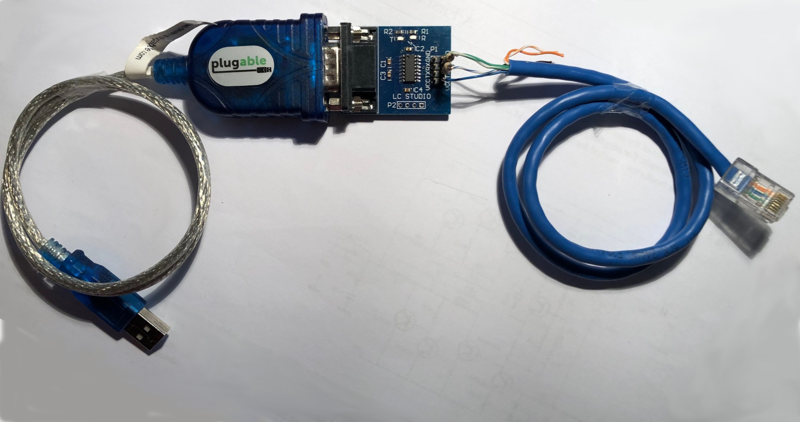

DIY
USB→E_Link programming adapter

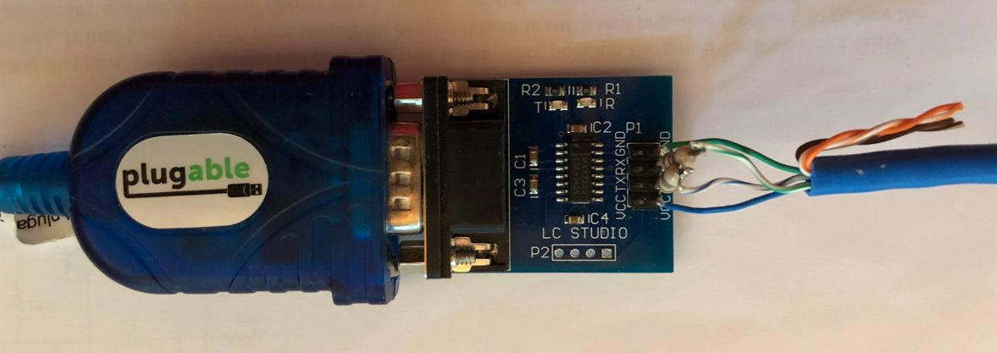

Wire connections to RJ45 cable

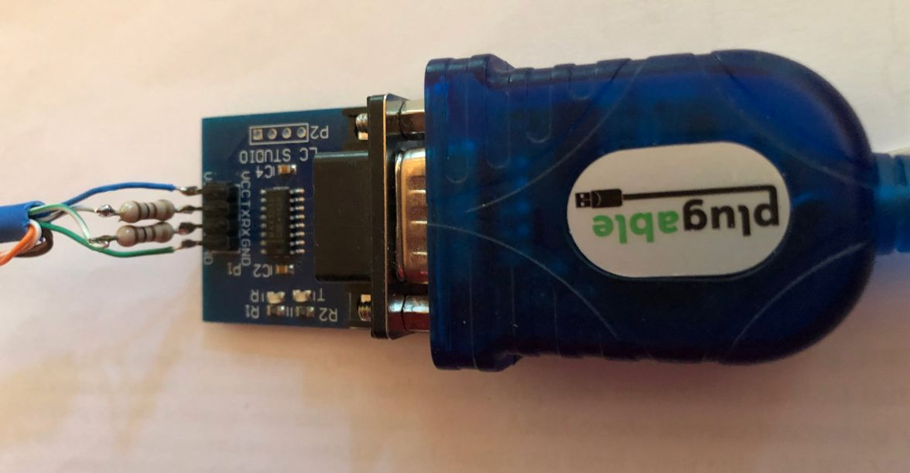

100 Ohm series resistors in TX and RX wires

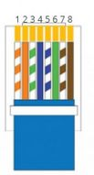
RJ45 (T568B) E2-Link connections

1 orange/white NC
2 orange NC
3 green/white RS232 – RX (*)
4 blue VCC (+5V)
5 blue/white RS232 – TX (*)
6 green GND
7 brown/white NC
8 brown NC

(*) It is recommended to use protective 100 Ohm series resistors in the RX and TX lines (see picture above).

The +5V VCC voltage for the RS232→ TTL level converter is delivered from the T+A device via pin4 of the E2_Link.

Notes:
(1) In stead of a USB→RS232 plus RS232→TTL adapter a direct USB→5V RS232 adapter might be used.

(2) The firmware update was tested with a Prolific PL2303 USB→RS232 adapter.

(3) Please make sure to use only adapters with an original Prolific chip set – there are quite a few (very cheap) adapters with non-original Chinese fake Prolific chips on the market: These non original Prolific chip sets will probably not work properly in this application !

(4) FTDI FT232R based USB→RS232 converters will also work, but the latency for these chips must be set to 1ms.
The latency for FTDI chips can be set in the Windows device manager:
Device_Manager -> Ports(COM&LPT) -> USB_Serial_Port (COMx) -> Port Settings -> Advanced -> Latency_Timer
Programming Procedure

- Start your Windows PC
- Connect the programming Adapter to your PC and to the E2Link socket of the DAC/HA200
- Switch ON your T+A device
- For FTDI based USB→RS232 adapters: set the latency in Windows device manager to 1ms
- Start the T+A E_Link Update Tool on your PC
- Click on the „Select COM Port“ button (see picture below)
  - A drop-Down list will occur.
- In the drop down list, select the COM port your programming adapter is connected to
- Click on the button „Select Device“
- From the drop-down list select the type of device you want to update (DAC200 or HA200)
- Click on the connect button
  - The T+A update tool will now check the communication with the device and check if the connected device matches with the selected device type.
  - If you get any ERRORS at this stage, please check the cabling, the USB-ES232 adapter and the settings
  - If you get the response „Success: all pre-checks completed. We are ready to start update“, click on the „Update“button.
- A file-selection window will open that permits to select the file with the new firmware.
  - Please note: The name of firmware update file must begin with „UPD_DAC_200“or „UPD_HA_200“
- Select the firmware file by double-clicking on it
- A „Start flash“ pop-up window will occur.
  - Press „Yes“ to start the update process or click on „No“ to cancel the update.
  - Note: this is the last chance to stop the update procedure. If you press „Yes“, the program memory in your T+A device will be erased and re-programmed.
- Wait until the update process is finished.
  - The update process will last a couple of minutes.
  - Please be patient, do not disturb the programming, do not switch OFF the T+A device, do not remove any cables!
  - You will be informed about the upgrade progress by a couple of messages on the PC screen and by a progress-bar in the lower left corner of the program window.
- After successful update, a pop-up window with the message „Update done“ will appear.
  - Click on „OK“ and restart your T+A device by pressing the Power button on the front panel of the DAC/HA_200.
- If you get a „Programming ERROR“ pop-up message, something went wrong.
  - By clicking on the „Yes“ button in this pop-up window you can re-start the update process

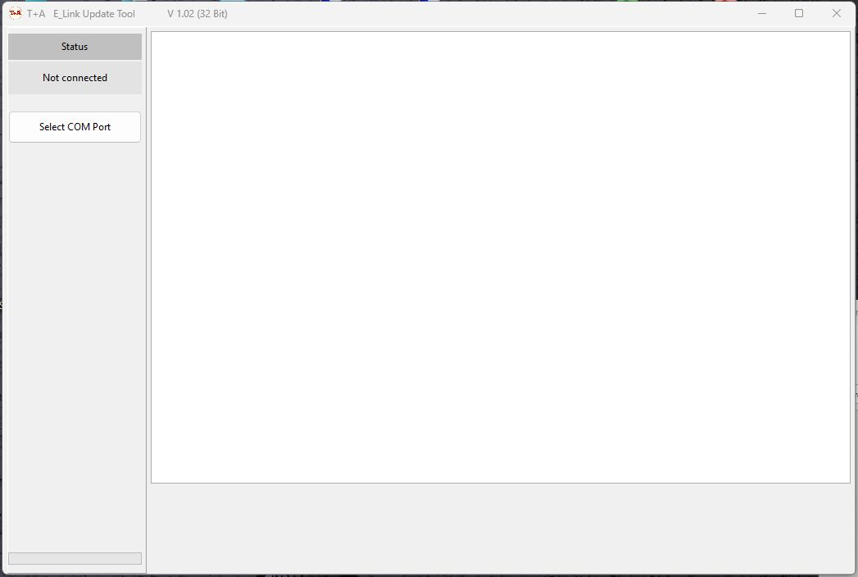

After program start:
select COM port.

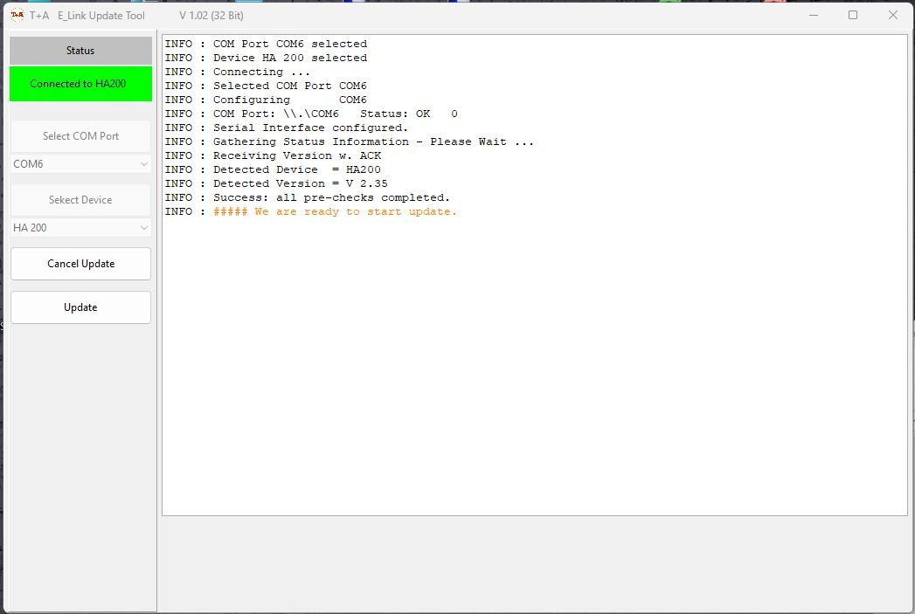

Pre-Checks done,
Ready to start update

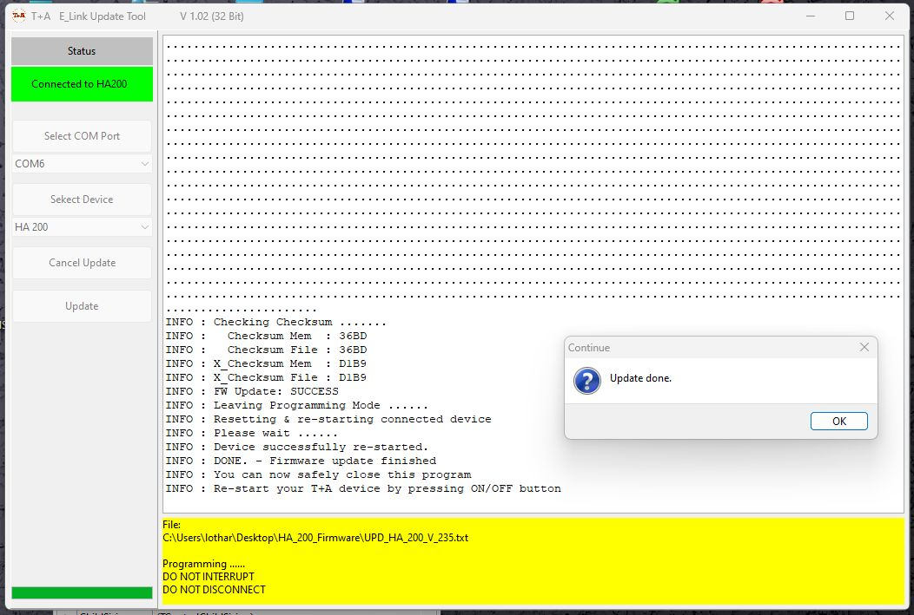

Update finished successfully

Device recovery

If during programming a severe fault occurred (like eg. a mains power interruption during programming or unplugging of the programming cable), the T+A device will be left with an erased or non functional program memory. In this case the T+A device will not work any more but it can be recovered with the help of the T+A Update Tool.

For recovery please proceed as follows:

- Disconnect the T+A device from the mains
- Leave it disconnected for about 2 minutes
- Re-connect the mains
- Start your Windows PC
- Connect the programming Adapter to your PC and to the E2Link socket of the DAC/HA200
- For FTDI based USB→RS232 adapters set the latency in Windows device manager to 1ms
- Start the T+A E_Link Update tool
  - The update tool will show the information that it has discovered a T+A device in Recovery Mode
- Select „Recover“
- Select the file with the device firmware
- In the „Start Flash“ pop-up window select „Yes“
- Wait until the program flash process has terminated.
- After successful device recovery, a pop-up window with the message „Update done“ will appear.
  - Click on „OK“ and restart your T+A device by pressing the POWER button on the front panel of the DAC/HA_200.

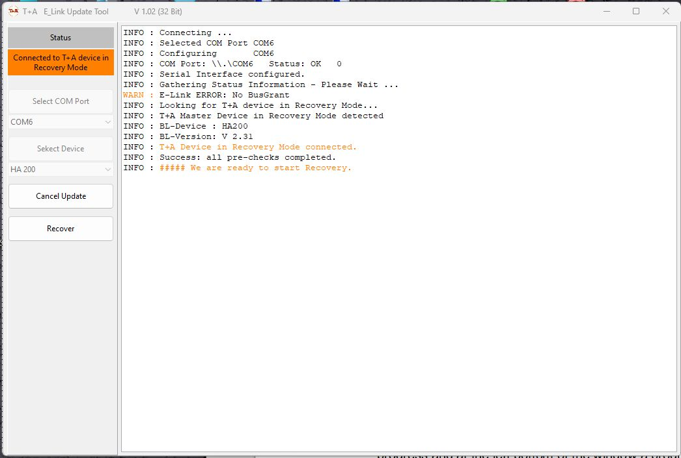

Update Tool after discovery of a T+A device in recovery mode

